

Company

Logotype

**Cone Beam Computed Tomography- Report**

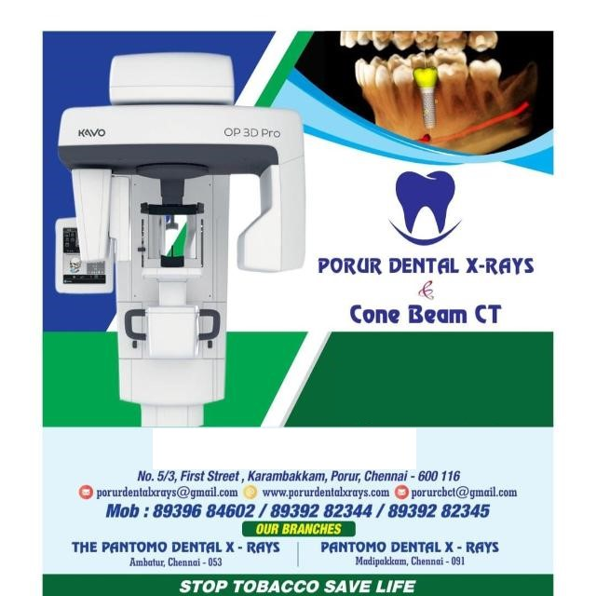



**Porur Dental X-rays & CBCT**

|  |  |
| --- | --- |
| **Patient Name :** Master. Guhan | **Date of Report :** 08.07.2024 |
| **Age/ Gender :** 7 years/ Male | **Region of Interest :** CBCT Mandible |
| **Referring doctor:** Dr. M. Balamurali Sai | **Indication :** Toassess lower anterior for supernumerary teeth and any abnormality in permanent incisors |
| **Clinical Notes:** Nil | |

**PATIENT INFORMATION**

CBCT Mandible provided

**CBCT – IMAGE DETAILS**

**RADIOGRAPHIC INTERPRETATION**

* Mixed dentition present.
* Permanent successors with adequate follicular space present in relation to 72, 73, 74, 75, 82, 83, 84, 85.
* The alveolar bone in relation to the mandibular ridge is present with normal trabecular pattern.

**RADIOGRAPHIC IMPRESSION**

* Mixed dentition phase with permanent successors.

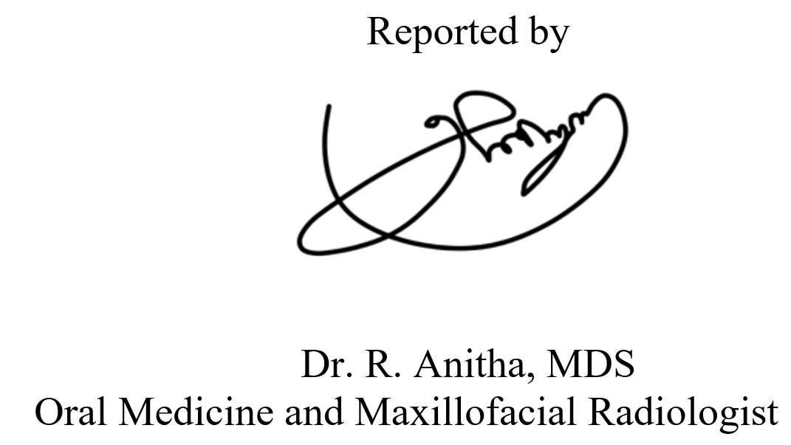

**IMAGES FOR REFERENCE**

**RECONSTRUCTED PANORAMA VIEW**

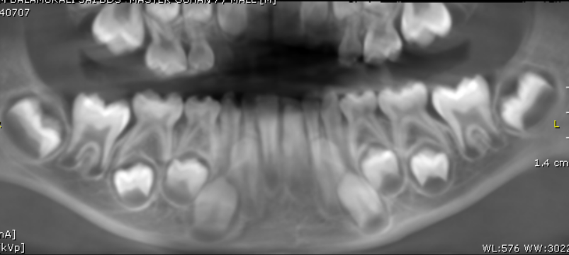

**3-DIMENSIONAL VIEW**

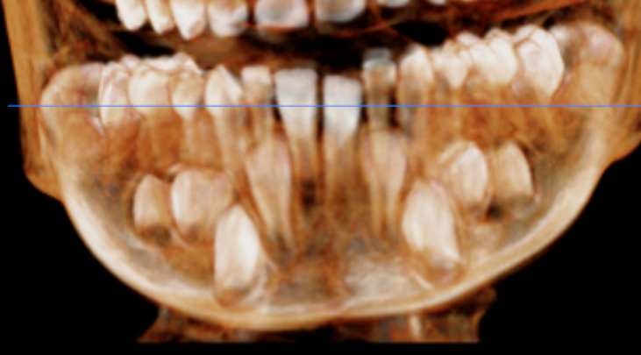

**35**

**34**

**33**

**32**

**425**

4

**435**

**445**

**455**

**CROSS- SECTIONAL IMAGES**

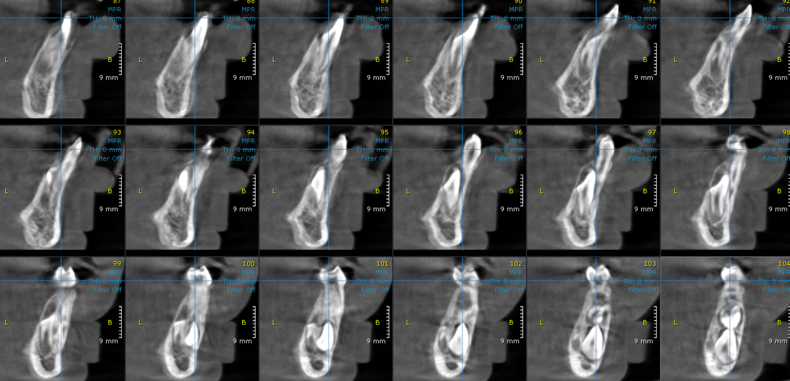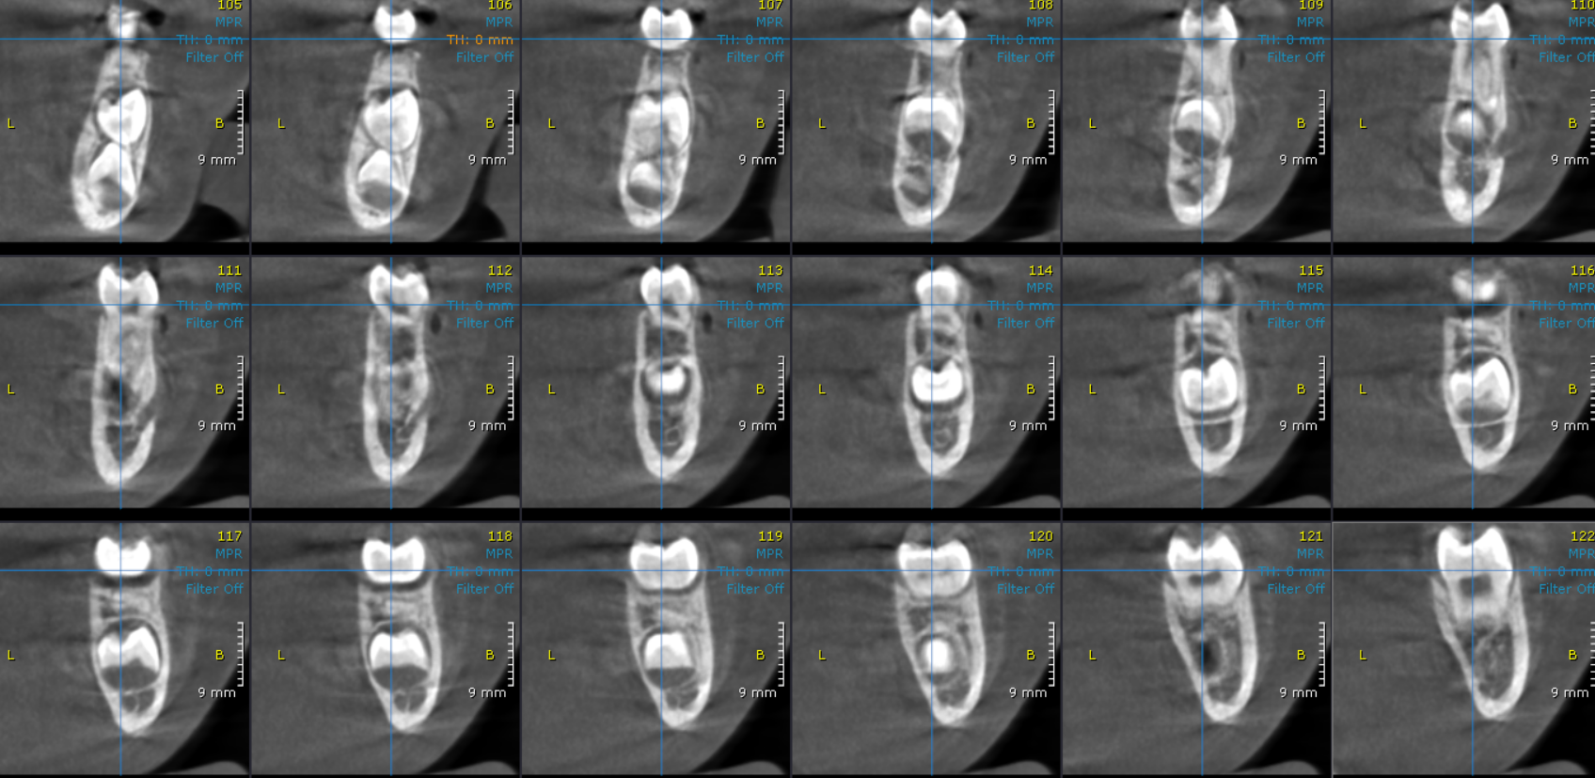

**35**

**34**

**33**

**32**

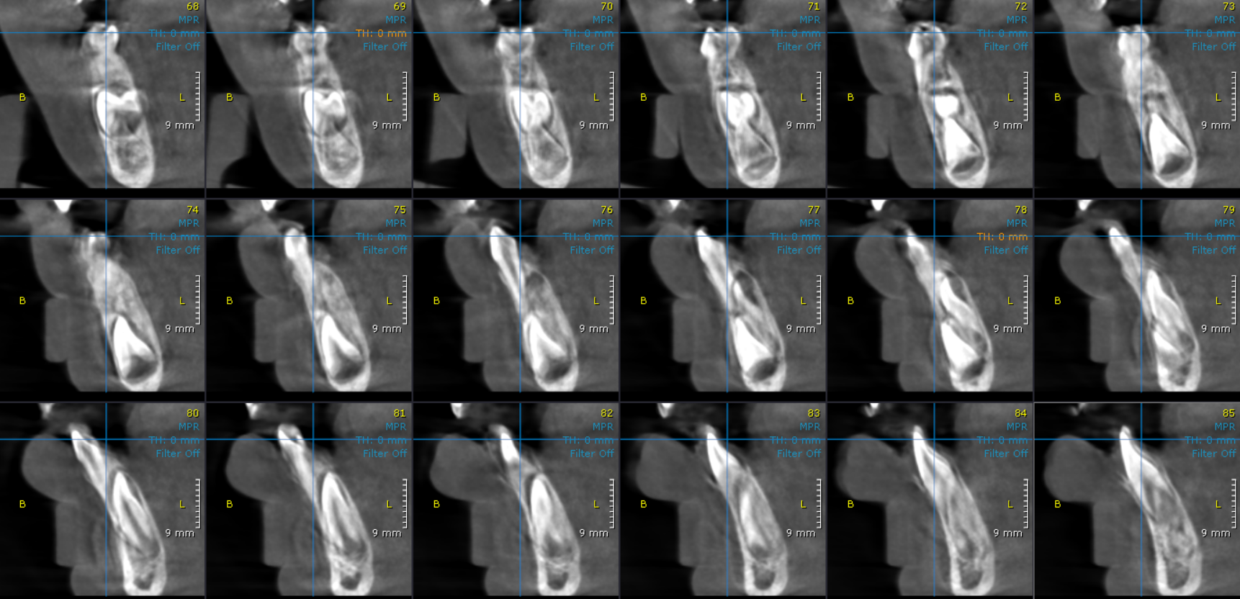

**445**

**435**

**425**

4

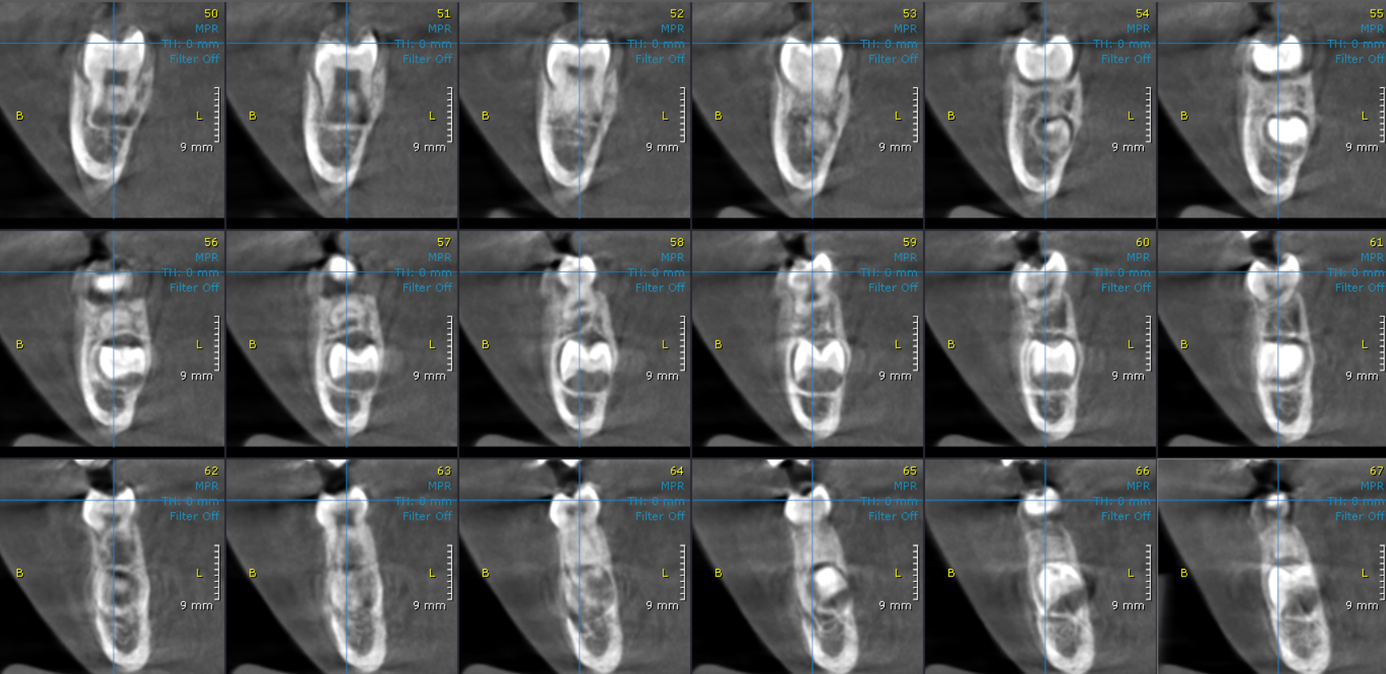

**455**

**\*\*\*\* End of report \*\*\*\***